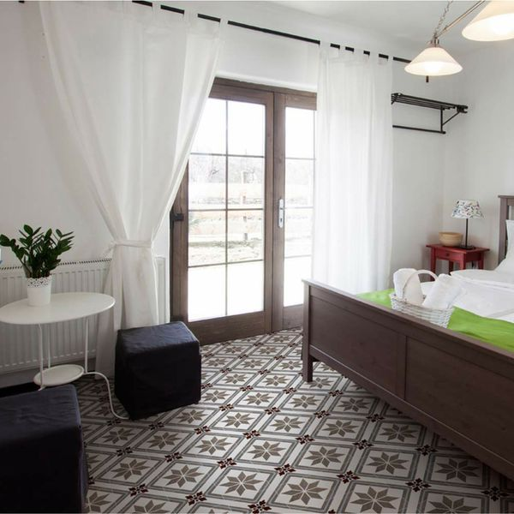

Memoir Encaustic Penzance Pattern Tiles: <https://www.wallsandfloors.co.uk/memoir-encaustic-effect-tiles-penzance-scored-tiles>

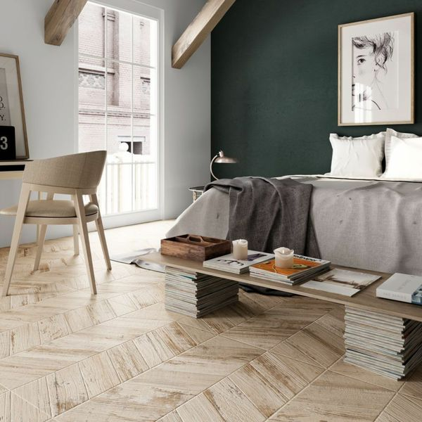

Caramel Varnish Chevron Wood Tiles: <https://www.wallsandfloors.co.uk/bococa-paintwash-wood-effect-tiles-caramel-varnished-chevron-wood-tiles>

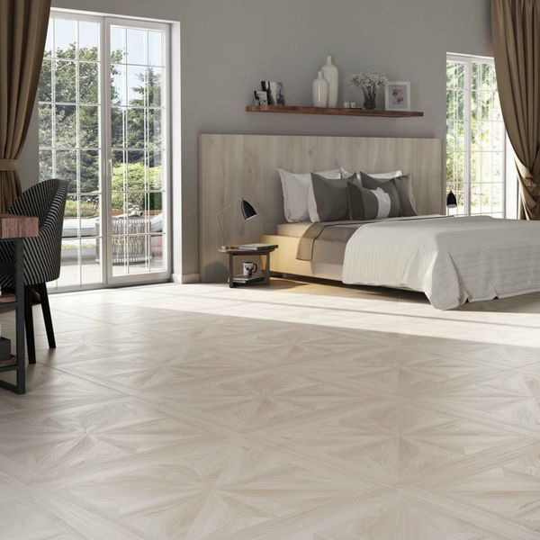

Antoinette Parquet Whiteleaf Jewel Wood Tiles: https://www.wallsandfloors.co.uk/antoinette-parquet-whiteleaf-jewel-wood-tiles